# **SNAPSHOTS VM**

To create vm with data disk example -120 GB

Now take the snap shot of os and data disk

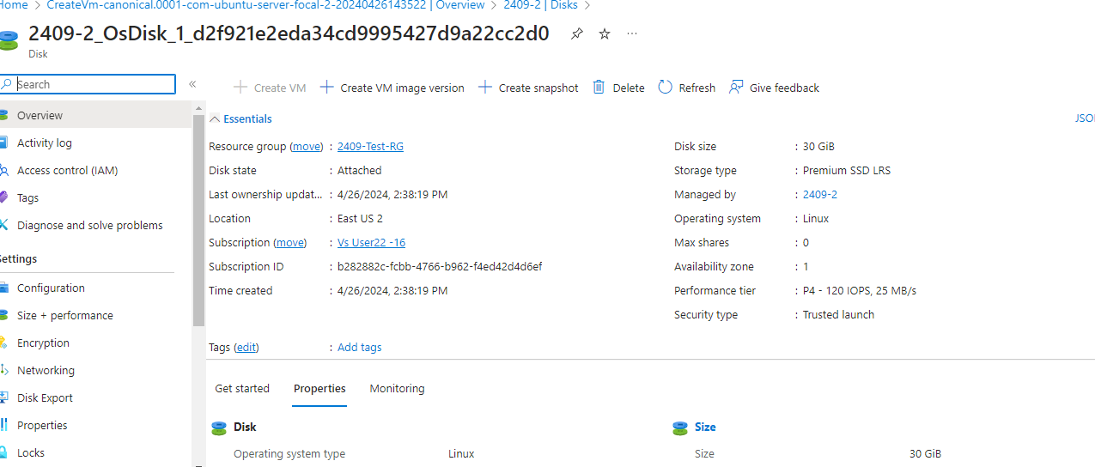

Now login to the VM and do the disk partition and mount the disk into a new folder

fdisk /dev/sdc

Welcome to fdisk (util-linux 2.34).

Changes will remain in memory only, until you decide to write them.

Be careful before using the write command.

fdisk: cannot open /dev/sdc: Permission denied

azureuser@2409-2:~$ sudo -i

root@2409-2:~# lsblk

NAME MAJ:MIN RM SIZE RO TYPE MOUNTPOINT

loop0 7:0 0 63.9M 1 loop /snap/core20/2182

loop1 7:1 0 91.9M 1 loop /snap/lxd/24061

loop2 7:2 0 39.1M 1 loop /snap/snapd/21184

sda 8:0 0 30G 0 disk

├─sda1 8:1 0 29.9G 0 part /

├─sda14 8:14 0 4M 0 part

└─sda15 8:15 0 106M 0 part /boot/efi

sdb 8:16 0 16G 0 disk

└─sdb1 8:17 0 16G 0 part /mnt

sdc 8:32 0 128G 0 disk

sr0 11:0 1 628K 0 rom

root@2409-2:~# fdisk /dev/sdc

Welcome to fdisk (util-linux 2.34).

Changes will remain in memory only, until you decide to write them.

Be careful before using the write command.

Device does not contain a recognized partition table.

Created a new DOS disklabel with disk identifier 0x1b70a0a6.

Command (m for help): n

Partition type

p primary (0 primary, 0 extended, 4 free)

e extended (container for logical partitions)

Select (default p): p

Partition number (1-4, default 1):

First sector (2048-268435455, default 2048):

Last sector, +/-sectors or +/-size{K,M,G,T,P} (2048-268435455, default 268435455):

Created a new partition 1 of type 'Linux' and of size 128 GiB.

Command (m for help): p

Disk /dev/sdc: 128 GiB, 137438953472 bytes, 268435456 sectors

Disk model: Virtual Disk

Units: sectors of 1 * 512 = 512 bytes

Sector size (logical/physical): 512 bytes / 4096 bytes

I/O size (minimum/optimal): 4096 bytes / 4096 bytes

Disklabel type: dos

Disk identifier: 0x1b70a0a6

Device Boot Start End Sectors Size Id Type

/dev/sdc1 2048 268435455 268433408 128G 83 Linux

Command (m for help): w

The partition table has been altered.

Calling ioctl() to re-read partition table.

Syncing disks.

root@2409-2:~# lsblk

NAME MAJ:MIN RM SIZE RO TYPE MOUNTPOINT

loop0 7:0 0 63.9M 1 loop /snap/core20/2182

loop1 7:1 0 91.9M 1 loop /snap/lxd/24061

loop2 7:2 0 39.1M 1 loop /snap/snapd/21184

sda 8:0 0 30G 0 disk

├─sda1 8:1 0 29.9G 0 part /

├─sda14 8:14 0 4M 0 part

└─sda15 8:15 0 106M 0 part /boot/efi

sdb 8:16 0 16G 0 disk

└─sdb1 8:17 0 16G 0 part /mnt

sdc 8:32 0 128G 0 disk

└─sdc1 8:33 0 128G 0 part

sr0 11:0 1 628K 0 rom

root@2409-2:~# mkfs.ext4 /dev/sdc1

mke2fs 1.45.5 (07-Jan-2020)

Discarding device blocks: done

Creating filesystem with 33554176 4k blocks and 8388608 inodes

Filesystem UUID: 463ea555-b9a1-4372-a0eb-b2278aa8482c

Superblock backups stored on blocks:

32768, 98304, 163840, 229376, 294912, 819200, 884736, 1605632, 2654208,

4096000, 7962624, 11239424, 20480000, 23887872

Allocating group tables: done

Writing inode tables: done

Creating journal (131072 blocks): done

Writing superblocks and filesystem accounting information: done

root@2409-2:~# mkdir /data

root@2409-2:~#

root@2409-2:~#

root@2409-2:~#

root@2409-2:~#

root@2409-2:~#

root@2409-2:~#

root@2409-2:~#

root@2409-2:~# mount /dev/sdc1

mount: /dev/sdc1: can't find in /etc/fstab.

root@2409-2:~# mount /dev/sdc1 /data/

root@2409-2:~#

root@2409-2:~#

root@2409-2:~#

root@2409-2:~#

root@2409-2:~#

root@2409-2:~# df -h

Filesystem Size Used Avail Use% Mounted on

/dev/root 29G 1.5G 28G 6% /

devtmpfs 3.9G 0 3.9G 0% /dev

tmpfs 3.9G 0 3.9G 0% /dev/shm

tmpfs 789M 1004K 788M 1% /run

tmpfs 5.0M 0 5.0M 0% /run/lock

tmpfs 3.9G 0 3.9G 0% /sys/fs/cgroup

/dev/loop0 64M 64M 0 100% /snap/core20/2182

/dev/loop1 92M 92M 0 100% /snap/lxd/24061

/dev/loop2 40M 40M 0 100% /snap/snapd/21184

/dev/sda15 105M 6.1M 99M 6% /boot/efi

/dev/sdb1 16G 28K 15G 1% /mnt

tmpfs 789M 0 789M 0% /run/user/1000

/dev/sdc1 126G 24K 120G 1% /data

root@2409-2:~#

root@2409-2:~#

root@2409-2:~#

root@2409-2:~#

root@2409-2:~# blkid

/dev/sda1: LABEL="cloudimg-rootfs" UUID="193443e5-f5e5-43ce-8232-767fde3c4d65" TYPE="ext4" PARTUUID="87dadcd0-a102-4b98-9ff4-38914f96fb00"

/dev/sda15: LABEL_FATBOOT="UEFI" LABEL="UEFI" UUID="57B4-0A8F" TYPE="vfat" PARTUUID="1a6a8f21-d21f-42d0-a562-eac988cb3cec"

/dev/sdb1: UUID="34c74775-f97a-46b7-87a8-852a9f430c5a" TYPE="ext4" PARTUUID="3910a77a-01"

/dev/loop0: TYPE="squashfs"

/dev/loop1: TYPE="squashfs"

/dev/loop2: TYPE="squashfs"

/dev/sda14: PARTUUID="cb7601f3-cc7e-4dd2-ad55-a07fd1b57fed"

/dev/sdc1: UUID="463ea555-b9a1-4372-a0eb-b2278aa8482c" TYPE="ext4" PARTUUID="1b70a0a6-01"

root@2409-2:~# nano /etc/fstab

root@2409-2:~# nano /etc/fstab

root@2409-2:~# mount -a

root@2409-2:~# lsblk

NAME MAJ:MIN RM SIZE RO TYPE MOUNTPOINT

loop0 7:0 0 63.9M 1 loop /snap/core20/2182

loop1 7:1 0 91.9M 1 loop /snap/lxd/24061

loop2 7:2 0 39.1M 1 loop /snap/snapd/21184

sda 8:0 0 30G 0 disk

├─sda1 8:1 0 29.9G 0 part /

├─sda14 8:14 0 4M 0 part

└─sda15 8:15 0 106M 0 part /boot/efi

sdb 8:16 0 16G 0 disk

└─sdb1 8:17 0 16G 0 part /mnt

sdc 8:32 0 128G 0 disk

└─sdc1 8:33 0 128G 0 part /data

sr0 11:0 1 628K 0 rom

root@2409-2:~#

Reference link <https://youtu.be/VsL2GN1KtI0>

Now create a file into the data disk

root@2409-2:~# cd /data

root@2409-2:/data# nano sample.txt

root@2409-2:/data# cat sample.txt

hello woelds

root@2409-2:/data# ls

lost+found sample.txt

Create disk using snapshots both OS and Data disks

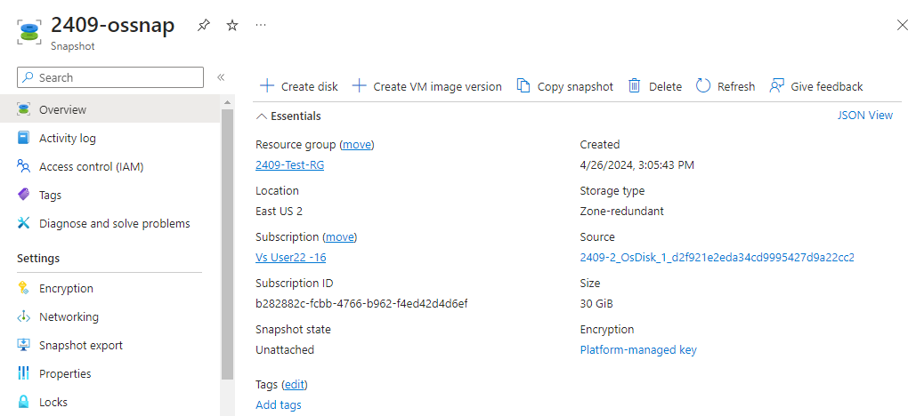

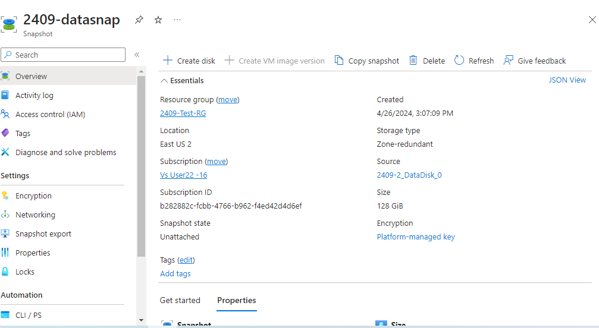

Now delete the vm

Go to OS disk and create a vm from it

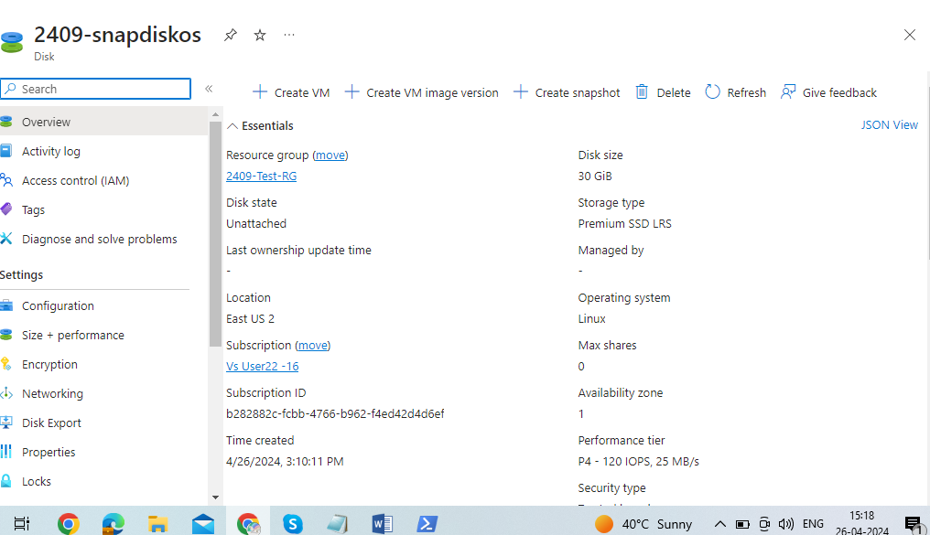

After the vm creates login and u can see the backup data like below

azureuser@2409-2:~$ sudo -i

root@2409-2:~# lsblk

NAME MAJ:MIN RM SIZE RO TYPE MOUNTPOINT

loop0 7:0 0 63.9M 1 loop /snap/core20/2182

loop1 7:1 0 39.1M 1 loop /snap/snapd/21184

loop2 7:2 0 91.9M 1 loop /snap/lxd/24061

sda 8:0 0 128G 0 disk

└─sda1 8:1 0 128G 0 part /data

sdb 8:16 0 30G 0 disk

├─sdb1 8:17 0 29.9G 0 part /

├─sdb14 8:30 0 4M 0 part

└─sdb15 8:31 0 106M 0 part /boot/efi

sdc 8:32 0 16G 0 disk

└─sdc1 8:33 0 16G 0 part /mnt

root@2409-2:~# cd /data

root@2409-2:/data# ls

lost+found sample.txt

root@2409-2:/data# cat sample.txt

hello woelds

root@2409-2:/data#